Ticker | JNJ 4.7 03/01/30
CUSIP | 478160DJ0
Maturity Date | 03/01/2030
Coupon | 4.7%
Rating | AAA/Aaa
Yield | 4.145258 (Bloomberg YAS)
Industry | Pharmaceuticals (B Class)
Currency | USD
Day Count | 30/360
Issue Spread | +35.00 bp vs T 4 ¼ 01/31/30
Recommendation (Buy/Sell?) | BUY

Investment Thesis

Buying the Johnson & Johnson 5-Year bond gives exposure to one of the world’s most stable companies, a competitive yield, and predictable income, all with the peace of mind that comes from investment-grade quality. It is a strong choice for conservative investors seeking income and capital preservation through 2030 in an increasingly volatile market.

Company Overview and Background
- Global healthcare leader with a diversified business model spanning Innovative Medicine and MedTech segments.
- Strong R&D investment drives innovation in neurology, oncology, and advanced surgical technologies, supporting a robust pipeline and steady growth.
- Exceptional financial strength; one of only two U.S. companies with AAA credit rating, reflecting prudent capital management and high resiliency.

Terms and Purpose
- Senior unsecured corporate bond issued February 2025 as part of a $5 billion multi-tranche deal; $1 billion size, $2000 minimum denomination.
- Fixed 4.7% coupon paid semiannually; matures March 1, 2030; callable at par from February 1, 2030.
- Includes standard senior unsecured covenants; negative pledge (restricts new secured debt unless bondholders are equally protected) and limits harmful structural changes for creditors
Credit Analysis
- J&J maintains a AAA/Aaa credit rating, reaffirmed by S&P in April 2025, reflecting conservative financial policies and strong acquisition track record.
- The company’s talc litigation remains manageable, with $7 billion in reserves and no expected large cash outflows (Bloomberg 2025).
- Financial capacity is robust: Q1 2025 sales grew 2.4% to $21.9 billion, with net earnings surging to $11 billion, driven by litigation charge reversals, and adjusted EPS up 2.2% (Yahoo Finance, 2025).
- Leverage rose to 1.4x post-acquisition but is projected to fall to 1.1x by year-end and below 1.0x in 2026, supported by annual operating cash flow exceeding $25 billion and strong free cash flow generation.
- Senior unsecured bonds are backed by an asset base across pharmaceuticals and MedTech, with $18.3 billion in PP&E and $15 billion in annual R&D investment.
Comparators (Table)
Company | Credit Rating | Coupon | Maturity | Yield % | Spread to Treasury (bps) | Sector
J&J | AAA/Aaa | 4.70% | 03/01/2030 | 4.15% | +35 bp | Healthcare
Pfizer | A+/A2 | 4.55% | 03/15/2030 | ~4.45% | +65 bp | Healthcare
Merck | A+/A1 | 4.40% | 03/01/2030 | ~4.30% | +50 bp | Healthcare
AbbVie | Baa2/BBB+ | 4.75% | 05/15/2030 | ~5.05% | +90 bp | Healthcare
Proctor & Gamble | AAA/Aaa | 4.45% | 02/01/2030 | ~4.10% | +30 bp | Consumer Staples
Yield and Concerns
- JNJ bond yields 4.15%, with tight spreads over Treasuries and only a small premium for credit risk, offering limited compensation compared to higher-yielding, lower-rated corporate bonds.
- Duration risk is significant, especially if interest rates rise, and long maturities amplify price sensitivity.
- Best suited for risk-averse investors seeking capital preservation, as AAA-rated issuers have near-zero default rates over decades.

Healthcare Sector

There is consistent demand for healthcare regardless of the economic cycle. J&J, being an industry leader and having a strong credit rating, underscores the reliability of their bond issuance. This is highlighted by aging populations (i.e., the Silver Tsunami) and the prevalence of chronic diseases. Amidst political change occurring within the U.S., other sectors may face greater challenges in terms of their own debt structure, making JNJ a safe investment.

Industry Competitors

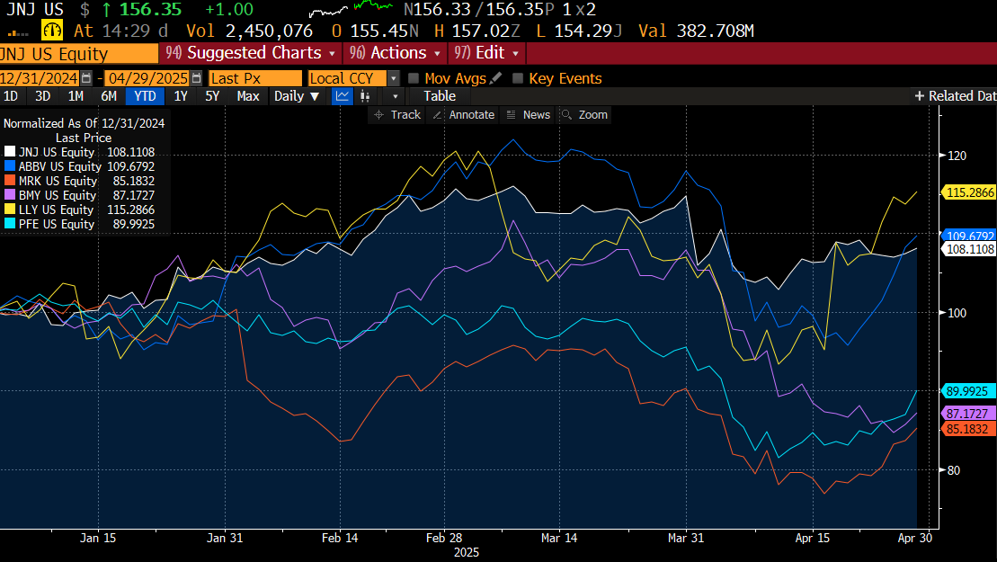
Legend (with normalized prices as of April 29, 2025)
Insights
- Eli Lilly (LLY) outperformed peers, potentially due to product pipeline strength or positive earnings surprises.
- AbbVie and J&J follow with modest returns, suggesting relative stability.
- Pfizer, BMY, and Merck have underperformed, reflecting weaker earnings, pipeline issues, or market sentiment.
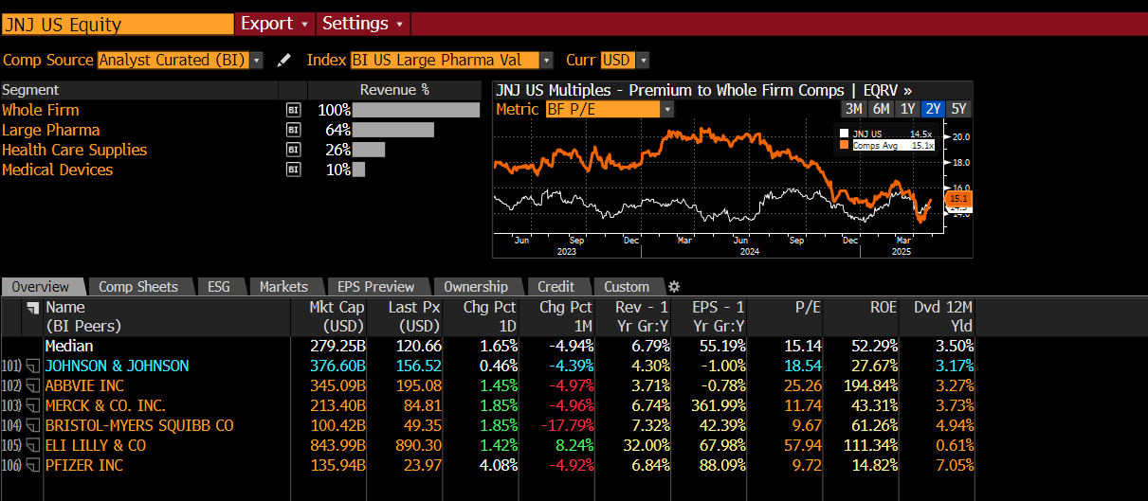
- Diversified healthcare firm with stable earnings and moderate dividend yield.

Key Ratios:

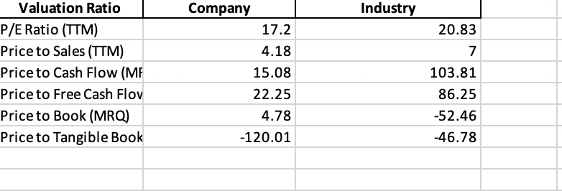

Bond Valuation

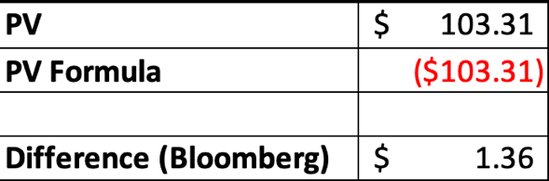

The bond valuation calculated a present value of $103.31. This aligns closely with Bloomberg’s quoted price, and the variance of $1.36 supports the accuracy of the cash flow model. We followed key bond metrics and found the annual discounted cash flows to properly calculate. Buy-Side Consensus
- Locking in Johnson & Johnson’s yield NOW offers potential for price appreciation with the Federal Reserve signaling further rate cuts.
- One of two AAA-rated corporate bonds, making it attractive in the highly volatile market environment.
- A defensive investment option, leveraging healthcare's consistent demand and low volatility, even during economic downturns.
Performance Potential vs. Risk
- Well-positioned for price gains if the Fed holds or cuts rates, as falling rates typically benefit high-grade, fixed-rate bonds.
- J&J’s financial strength and high demand for top-tier income make the bond appealing for conservative portfolios, ensuring price stability and consistent income.
Risk Consideration
- Rising interest rates could reduce bond prices; duration risk is significant.
- Callable at par February 1, 2030, exposing investors to risk if J&J redeems early in a lower-rate environment.
- Minimal but not zero credit risk due to ongoing talc litigation and contingent liabilities, despite large reserve allocations.
- Liquidity risk is moderate; trading volumes may drop in stressed markets.
- Narrow spread over Treasuries offers limited compensation for credit, liquidity, or event risks compared to lower-rated corporate bonds.
Summary and Recommendations
Johnson & Johnson 4.70% 03/01/2030 is best suited for conservative investors seeking stability with reliable income. While its upside is limited by tight spreads and callability, its unparalleled credit strength and industry stability earn it a core portfolio holding in a diversified portfolio of fixed income to preserve capital.
Action Plan
- Core Holding: Use as a moderate, core fixed income position for capital preservation and steady income; buy now to secure current yields before potential Fed rate cuts.
- Risk & Monitoring: Limit callable bond exposure, maintain portfolio liquidity, and monitor interest rates, J&J’s credit/litigation status, and call risk near February 2030.
- Review and Compliance: Reassess and rebalance semi-annually; document actions to ensure alignment with investment policy.

